In-track Pressure Testing at Tie-Ballast Interface using Pressure Cells
Jordan P. Haney¹, Jerry G. Rose¹, Macy L. Purcell¹, and Reginald R. Souleyrette¹
¹ Department of Civil Engineering, University of Kentucky, Lexington, KY

A method was developed for measuring distributions of railway trackbed pressure magnitudes at the tie-ballast interface using earth pressure cells placed directly under the tie along its length. A locomotive was used to provide typical pressures at the wheel/rail interface. The method was determined to provide consistent and repeatable results.

Introduction
The purpose of this research project is to determine in-track pressure magnitudes at the tie-ballast interface using a locomotive and earth pressure cells.

Testing Location and Method
The in-track tests were conducted on the yard lead track from the CSX interchange at the Transkentucky Transportation Railroad Yard in Paris, KY. The track, consisting of 132RE jointed rail and wood ties, is basically supported by moderately fouled ballast, similar in gradation to typical subballast. The maximum track speed is 10 mph. A typical 4-axle locomotive was used.
Pressures were recorded at the tie-ballast interface using Geokon Model 3500-2 Earth Pressure Cells. The three cells were placed directly under a single tie -- under both rails and the center of the tie -- as shown in Figure 1.
In order to place the cells under the tie, the ballast was removed from the crib on one side of the tie. The track was raised using track jacks. Particular attention was given to insure that the ballast below the tie was not disturbed so that the recorded pressures would be indicative of in-track conditions. With the track raised, the cells were placed under the tie at the positions shown in Figure 2.
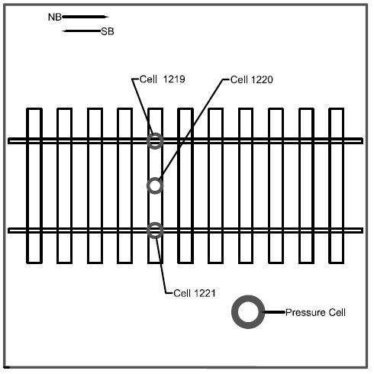
Figure 1: Cell Location Diagram
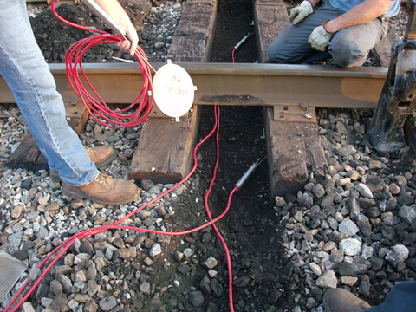
Figure 2: Installation of Pressure Cells in Track
After the cribbing ballast was placed back in the crib, the track jacks were lowered so the top of the tie would be firmly in contact with the cells. A Campbell Scientific CR-300 Data Logger was used to record the data. The data logger records the voltage readings which are generated when loads are applied to the cells.

In-Track Tests
In-track tests were conducted using loading from a 4-axle 263,000-lb locomotive moving in northbound and southbound directions across the instrumented tie. The tests were conducted with the train moving at constant speeds of 5 mph and 10 mph. Tests were also conducted with the portions of the locomotive statically positioned directly over the instrumented tie. Figure 3 shows the locomotive.
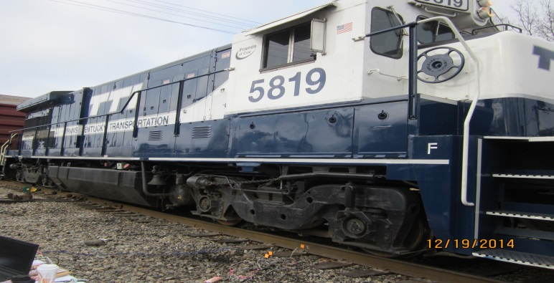
Figure 3: Testing using a 4-axle locomotive

Data Analysis
Several data sets were taken using multiple run-byes with the locomotive. Figure 4 shows typical pressure readings for the locomotive traveling 5 mph in the northbound direction. 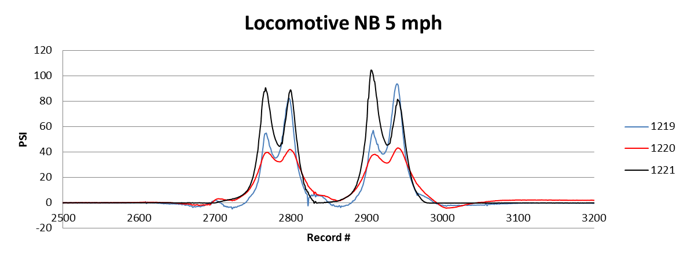
Figure 4: Pressure Reading for Locomotive Moving Northbound at 5mph
The pressure traces for the three cells, positioned as shown in Figure 1, are superimposed on the color-coded plot. The pressures increase as the lead axle approaches the instrumented tie, then decrease as the center of the truck passes over the tie. As expected, the rear axle produces similar pressures as the lead axle. Each peak pressure on the plot corresponds to the pressure when the axle is directly over the tie.
The pressure peaks are fairly consistent, typically near 90 psi, for each axle as it passes over the tie. Slight differences are seen as the rail joints produce some rocking of the locomotive. Multi-test passes were made in both directions. The data was very consistent and repeatable.
Additional tests were conducted to determine the effect of increasing the speed of the locomotive. Figure 5 shows typical pressure readings for a locomotive traveling at 10 mph in the northbound direction.
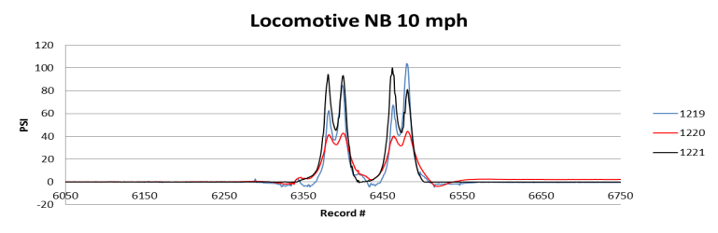
Figure 5: Pressure Reading for Locomotive Moving Northbound at 10mph
The magnitudes of the 10-mph pressure readings are similar to the 5-mph pressures as shown in Figure 4. The pressures increase as the lead axle approaches the instrumented tie similarly to the 5-mph tests. The peaks occur closer together reflecting the effect of the higher speed of the locomotive. Multi test passes were made in both directions. The data was very consistent and repeatable.
The final series of tests were conducted under static loading. The lead axle of the lead truck, the center of the lead truck, the training axle, and the center of the locomotive were positioned over the tie for periods of 5 seconds. Figure 6 shows the pressure readings for the locomotive during the static tests.
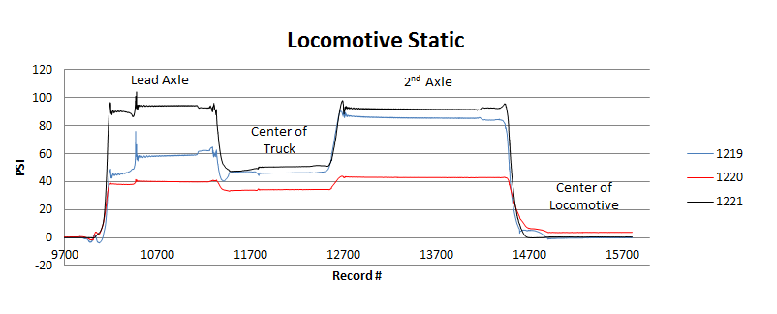
Figure 6: Pressure Reading for Locomotive Static Test
The pressure readings from the static tests indicated that the static pressures are similar in magnitude to the 5 and 10-mph tests.

Summary and Future Research
Geokon Earth Pressure Cells, for measuring pressures at the tie-ballast interface under locomotive loading, yielded consistent and repeatable readings at 5 mph, 10 mph, and static loading conditions.
Future testing will include prototype laboratory tests to determine pressure distributions throughout a track panel loaded with a conventional freight car truck. Additional pressure magnitudes and distributions will be determined from in-track tests on high-tonnage, high-speed rail lines.
The authors would like to thank the National University Rail (NURail) Center, a US DOT-OST Tier 1 University Transportation Center for sponsoring this study. We would like to thank the following individuals for their contributions: Russell Rogers and his Staff at Transkentucky Transportation Railroad (TTI).

